CS130/230
Introduction to PowerPoint

What is Microsoft PowerPoint XP?

Microsoft PowerPoint XP is a presentation graphics software package and can be used to produce professional presentations, slides, handouts, speaker’s notes, and outlines. Before we begin, it is useful to know what PowerPoint is not:

- A graphic design package. PowerPoint is not well-suited to drawing pictures.
- A publication designer. PowerPoint is not well-suited for designing brochures, newsletters, circulars, or handouts.
- A word-processor. PowerPoint is particularly poorly suited to producing text-rich documents.

Today we will learn how to create a basic PowerPoint presentation.

The PowerPoint Interface: An overview

When you initially open up PowerPoint, you will be greeted with an interface that looks similar to other MS Office products. Some things I will point out on the interface in class are: Views, Drawing Toolbar, Standard Toolbar, Formatting Toolbar, Currently Visible Slide, and Design Template in Use.

Viewing Toolbars

The tools that you will use to add content to the slides are found on the toolbars that appear at both the top (Standard, Formatting) and bottom (Drawing, etc.) of the screen. If one of the toolbars is not visible, select View->Toolbars from the Menu bar and choose the appropriate toolbar. A checkmark next to the make indicates that the toolbar is currently visible.

Starting your own presentation

- (Slide 1) Enter a title for your first slide by clicking on the top box and typing. You can click on the second box and add additional information such as your name, etc.
- Now click on the new slide icon on the standard toolbar or select Insert->New slide from the menu.
- PowerPoint will automatically bring the default layout (title) to the new slide and open the Slide Layout pane on the right hand side of the presentation window. To continue developing the presentation we need to select a new layout for the new slide. Note that PowerPoint XP has a variety of present layouts for slides, and these are organized as Text Layouts, Content Layouts, and Text and Content Layouts and are presented in the Slide Layout pane.
- (Slide 2) Select the Title and Text option and type the slide title and add some text to the list. Notice that you can use the Tab key to create an indented sub-list (Shift-Tab returns you to your initial bulleted list).

Inserting a picture from the Clipart Gallery

(Continue your presentation)

- (Slide 3) Click on the New Slide icon again to create your third slide. Choose the Title, Content and Text layout from the New Slide dialog box and choose the “Picture” icon (the one with the picture of a person) from the menu in the picture portion of the slide: 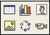 This will allow you to add an image from the Microsoft Clip Art Gallery. Select an image, and select OK.

To resize an image, grab a corner handle and drag to shrink or expand the image. NOTE: Don’t grab a handle that is not on the corner as it tends to distort the image.

Inserting a picture that you previously saved

(Continue your presentation)

- (Slide 4) Click on the New Slide icon and choose Title Only from the Auto Layout options (on this slide we will add our own graphics and text). Now, type in a title for the slide. To add a picture that you have previously saved on disk, from the Menu select Insert->Picture->From File.

Add text to the slide by clicking on the Text Box icon on the Drawing toolbar at the bottom of the PowerPoint window. Click anywhere on the slide to begin typing your text. Once the text has been entered, you can drag the handles on the edge of the box to adjust the height and width. To move the entire block of text, click once to select the text box and drag the box by a border rather than a handle.

Inserting a chart:

(Continue your presentation)

- To insert a chart, click on the new slide icon and choose the Title, Text and Content option from the Slide Layout options. In this slide, select the chart icon from the options and replace the information in the cells of the datasheet with different numbers of labels and the chart will reflect your changes. Once you have modified your chart, add bulleted text to the slide.

Using the PowerPoint Views

Up until now we have been working in Slide View mode, which is used to create and edit individual slides. Other views allow the user to change the order of slides in a presentation, create speaker notes to accompany the slides, to view the completed slide show, or to control animation within each slide or animation between slide transitions. To change views, click on one of the icons in the lower left corner of the PowerPoint window:

- Normal View: Used typically to write and design the presentation. Notice that within the this view you can also select Outline View and Slides in the upper left hand portion of the screen.
- Slide sorter view: This displays thumbnail images of all slides in order. This is useful in controlling animation between slide transitions and for controlling the order of the slides (simply click and drag a slide to the desired location).
- Slide Show view: This displays a full-screen version of each slide as it will appear during the slide show presentation, beginning with the present slide.

Changing the Appearance of the Slides

Preset Design Schemes and Templates

From the menu select Format->Slide Design. A slide design box should appear that lists the available design templates. Scroll and make your selection; it will be automatically applied to your presentation. If you want to take off the applied design, select the default design in the upper left hand corner of the “Available Designs” box.

Background Color and Pattern

- Change the background color of your slides, make sure you are in the Slide Sorter View so you can see thumbnail images of all your slides.
- Select Format->Background from the menu.
- The Background dialog box will appear. Select a new color from the pull-down menu. If the color you want is not visible, select More Colors. You can also select Fill Effects to add gradient, texture, patterns, or a picture to the background.
- Click Apply to All to apply the new color or pattern to all of your slides. Click Apply to apply the color or pattern just to the selected slide.

Editing Color Schemes

PowerPoint’s present color schemes include background and font colors as well as bullet, chart, shadow, and hyperlink colors. Custom color schemes can be also created and saved.

Select Format->Slide Design the click on Color Scheme in the upper right corner of the screen. You can select any of the pre-formatted color schemes by just double clicking on any scheme, or you can apply your own colors by clicking on Edit Color Schemes at the bottom of the dialogue box and doing on of the following:

- Click on the Standard tab and select a preset color scheme from the available options OR
- Click on the Custom tab and select your own colors. Click the Add as Standard Scheme button to save your custom settings for later use. Your color scheme is added as a Standard scheme.

After doing A) or B), click Apply to apply the color scheme only to the select slide or click Apply to All to apply the scheme to all slides.

Formatting a chart

Nearly every part of a PowerPoint chart can be formatted independently, giving you a great deal of control. PowerPoint charts are made up of many differently named regions that may or may not be obvious to the user.

- First, identify the different regions of the chart by double-clicking on the chart to select it then holding your mouse pointer over any part of the chart. The name of the region will pop up. Mouse-over the entire chart area until you have identified the following regions: chart are, plot area, legend, category axis, value axis, walls, and data series.
- Each of the named chart regions can be formatted independently, meaning each can contain a different font, style, background, or fill color, etc. Double click on the region you would like to format and the appropriate dialog box will appear.

Drawing toolbar

The drawing toolbar at the bottom of the screen allows the user to change the appearance of existing objects and add graphical elements to PowerPoint slides:

The additional menus Draw and AutoShapes are particularly useful when drawing objects:

Word Art

Special WordArt effects and be created quickly and easily using the Draw toolbar. Choose a present style from the WordArt gallery, or create custom color, shadow, and alignment effects.
- Click on the Insert WordArt icon in the drawing toolbar. The WordArt Gallery appears.
- Select a WordArt style from the gallery and click OK. The Edit WordArt Text dialog box appears.
- Select a font face and size, type in your text, and click OK.
- If desired, use the WordArt toolbar to change the color, shape, spacing, alignment, rotation, or text of your WordArt.

Transition and Animation

Slide Transition Effects

You can create special transitions, such as dissolve, fade, uncover, and wipe, between slides in your slide show.

- Make sure you are in the Slide Sort view.  - Click Slide Show->Slide Transition on the toolbar. The Slide Transition box should appear (shown at right)  - Change the settings as desired; it will automatically apply to the selected slide, or select Apply to All. | 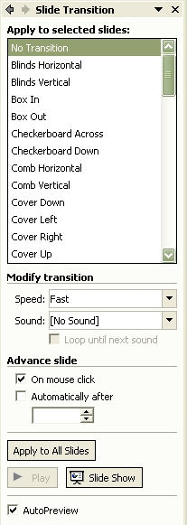

Text, Image, and Chart Animation (see above)

Slides containing a combination of text, images, and charts can be animated manually so you can determine the order in which objects appear.

- Make sure that you are in Slide view.  - Select Slide Show-> Custom Animation from the Menu bar. The Custom Animation dialog box appears (shown at right)  - Select the objects on the slide to be animated. Click on the Add Effect and select Entrance, and pick one of the options. You can also see other options by clicking on More Effects at the bottom of the dialogue box.  - Use the arrow buttons to arrange the order in which the animated objects should appear on the slide (rearrange objects in the Animation Order window).  - You can select the speed of the effect from the Speed selection box.  - You can also modify how the effects begin; you can have one at a time, simultaneous effects, or automatically one after the other by selecting the appropriate option on the Start box. | 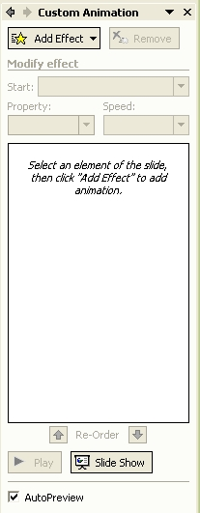

Final Output Options

Print
- Select File->Print from the menu. The Print dialog box appears.  - Select a printer under the Name heading.  - In the Print Range area, select the slides to be printer  - In the Print What area, select the desired format: one slide per page, handouts (up to 9 slides per page), speaker notes, or outline view.  - Select whether to print in Black & white or color in the Color/greyscale area:  - Click OK to begin the print operation. | 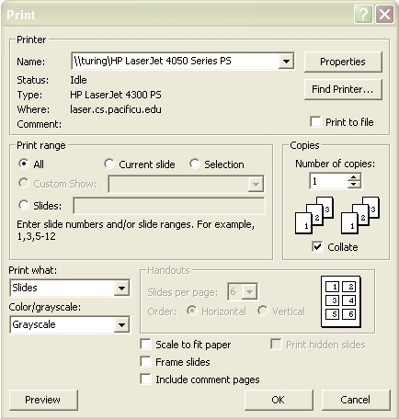

Save

Notice that when you select File->Save As from the tool bar, that you can control how the file is saved under the Save as Type section. This allows you, among other things, to save the file as a webpage.

Notes on Style
- Using templates avoids the need to make design decisions
- Keep it simple
- The fewer bullets on a page the better
- Graphics should compliment, not distract
- Contrasts should be sharp
- Avoid red except for very important points
- Animated graphics are distracting, generally.
- Consistency in backgrounds is a virtue.
- If you change backgrounds, change them for a reason.
- Do not let a clever background obscure the content.

